**Trainee management system**

Entities:

1. Trainee
2. Courses
3. trainer
4. Batch
5. Enrolments
6. Payment
7. Certificate

Attributes:

1. Trainee:
2. Trainee_id {primary key}
3. Name
4. Age
5. Gender
6. Contact number
7. Email
8. Address fk
9. Nationality
10. Date of birth
11. College/school
12. Courses:
    1. course_id pk
    2. course_name
    3. description
    4. Duration
    5. StartDate
    6. EndDate
    7. TrainerID fk
    8. Status The status of course (e.g., upcoming, ongoing, completed, canceled).
    9. fee

1. Trainer
2. TrainerID pk
3. Name:
4. Age
5. Gender
6. Contact number
7. Email
8. Address
9. Designation
10. Batch:
11. BatchID pk
12. CourseID fk
13. TrainerID fk
14. StartDate
15. EndDate
16. Location:
17. Capacity
18. EnrolledTrainees:
19. Status The status of the batch (e.g., upcoming, ongoing, completed, cancelled).
20. Enrolments:
21. EnrollmentID pk
22. TraineeID fk
23. BatchID fk
24. EnrollmentDate
25. Status The status of the enrollment (e.g., enrolled, completed, dropped, pending).
26. Payment status
27. Payment date
28. CertificateIssued (true or false)
29. CertificateID: fk
30. Payment:
31. Paymentid pk
32. Traineeid fk
33. Batched fk
34. Payment date
35. Payment amount
36. Payment method
37. Payment status
38. certificate
39. CertificateID pk
40. TraineeID fk
41. BatchID fk
42. CourseID fk
43. IssueDate
44. IssuedBy

**Tables:**

1. trainee_details_tbl

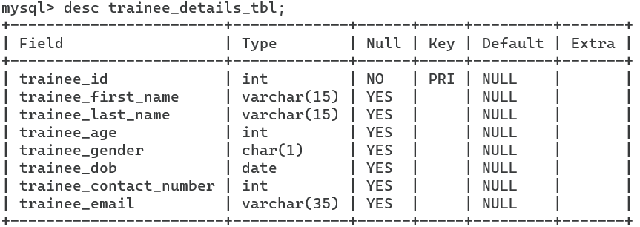

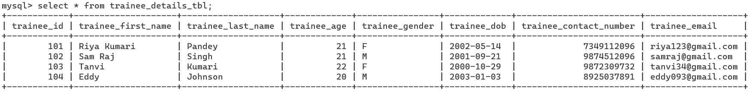

1. address_details_tbl

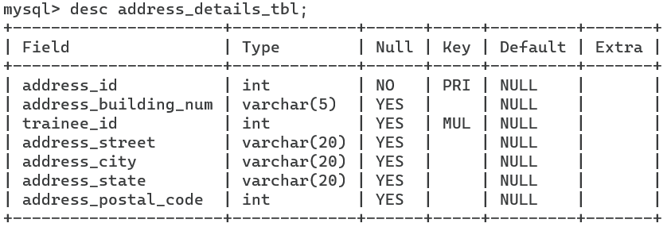

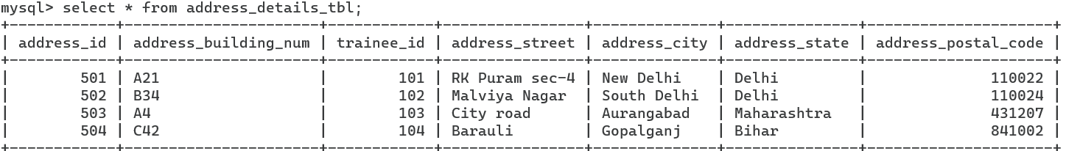

1. college_details_tbl

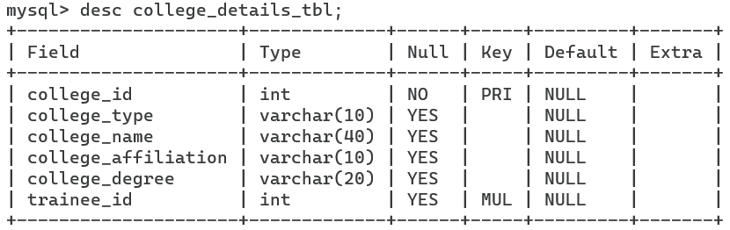

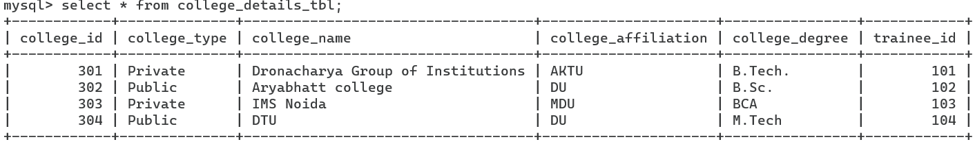

1. trainer_details_tbl

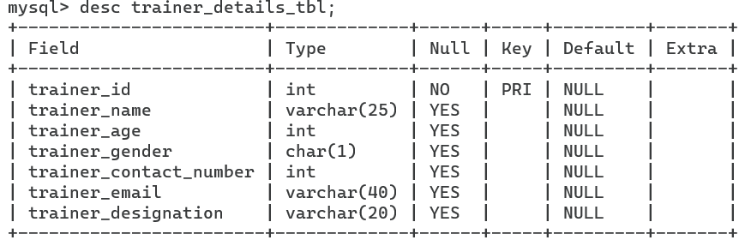

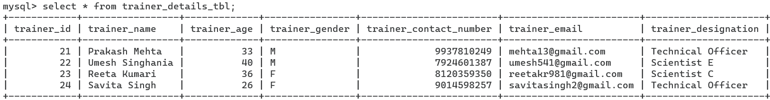

1. courses_details_tbl

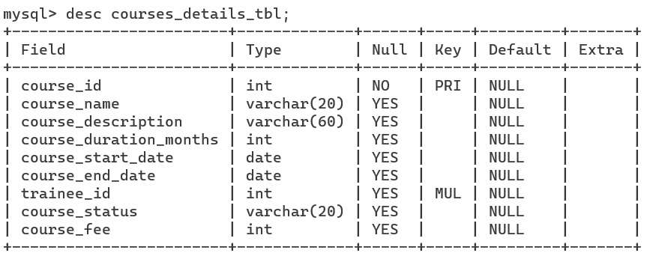

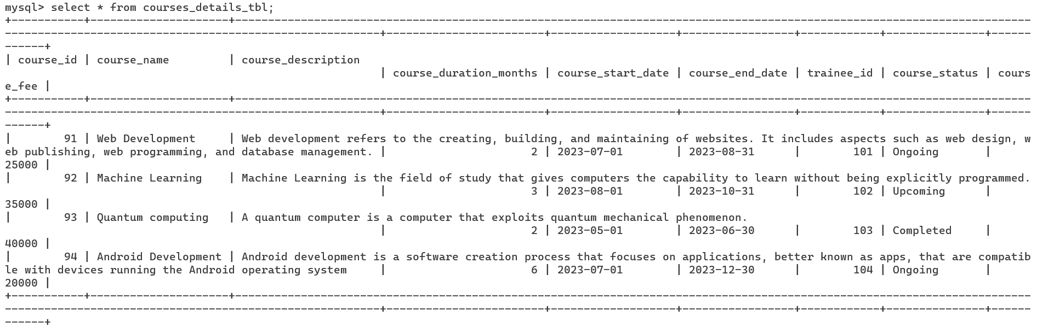

6.batch_details_tbl

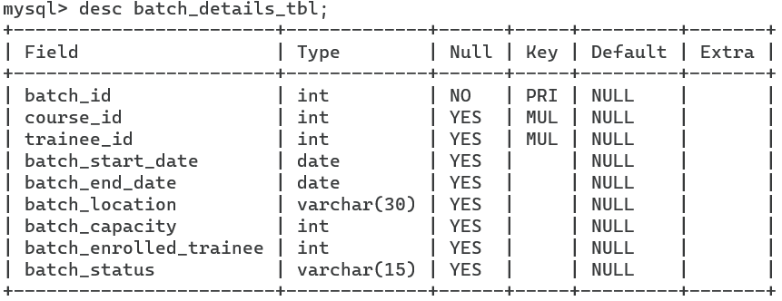

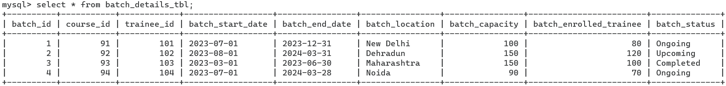

7.enrolments_details_tbl

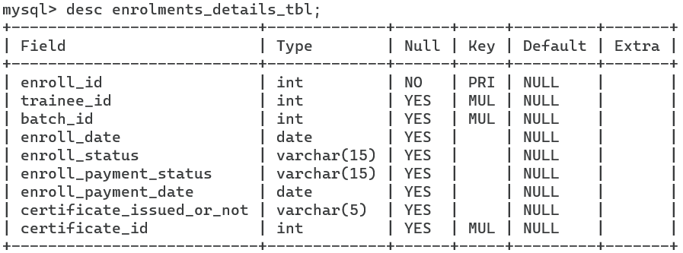

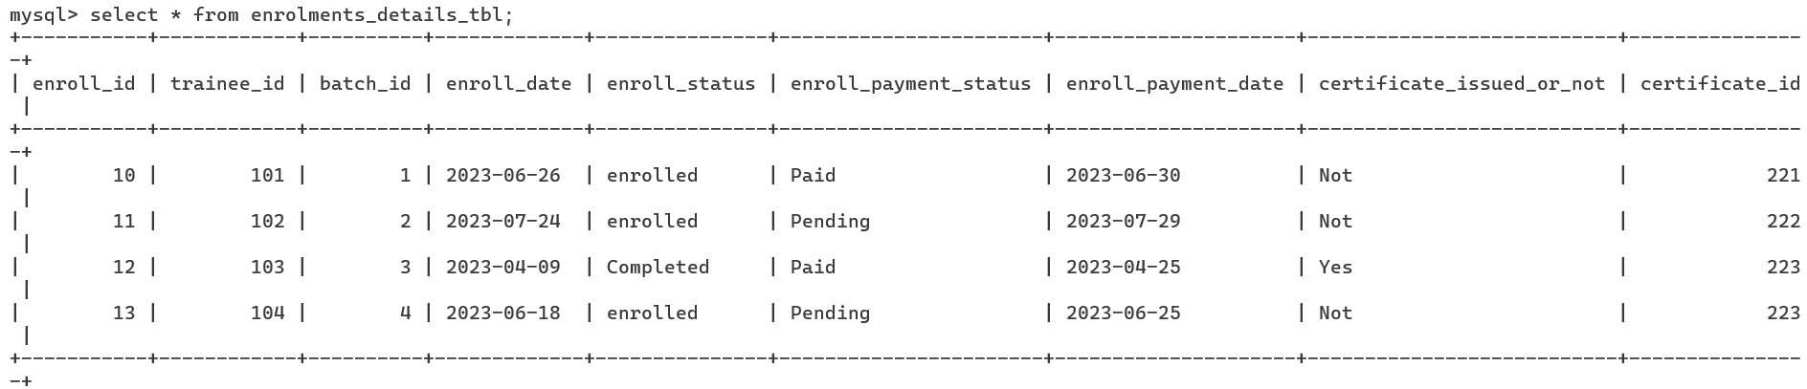

8.certificate_details_tbl

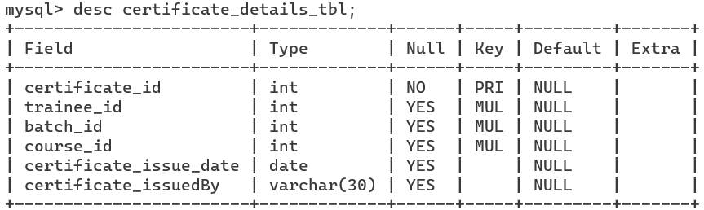

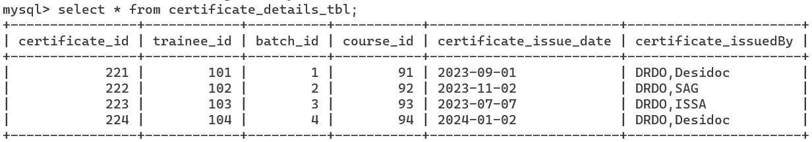

9.payment_details_tbl

